Website Speed Ranking
The loading speed of your website has a significant impact on your ranking on search engines such as Google. Obviously without good content you won’t make it at the top of the charts either.
Nonetheless, if you share your website links and content on social media or other platforms people expect that your website will load in a few seconds.
Longer load times will result in bounce, a technical term meaning that a visitor goes on your website and leaves either because the website was too slow, broken or the content was what they expect. When this occurs it sends feedback to the social media platform and search engines which will decrease your visibility and the amount of traffic they send you.
Using 2017 data (source Ignite Visibility) we’ve created this easy table that helps you understand how many visitors you are losing to competitors as your Google ranking decreases for a specific search term. We’re also including a tool for you to test your website speed.

Test Your Website Speed Using Pingdom (Free)
Determine the load time when a visitor first starts to see content on any webpage of your site using the free tool at https://tools.pingdom.com/ . The faster the better. You will want to review the Kissmetrics data on the impact of loading time on your visitors and sales to better interpret your website speed.
- Visit https://tools.pingdom.com/
- Enter the complete URL of the page you want to test. Your homepage is a great page to test. Enter the complete URL using http:// or https:// as relevant. You can visit your website, copy the URL and then paste it in Pingdom.
- Run the test twice with the second test being your result. This is to account for caching and other technology which speeds up your page. We won’t go in a technical analysis here!
- Review the Kissmetrics data to interpret your results.

Website Speed Optimization Example
We worked with our client website kimberliecarlson.com to optimize her website speed. First we converted the site from http:// to https://kimberliecarlson.com to ensure that it gets maximum ranking and that no security warning shows in the visitor’s internet browser.
Then we optimized the content, coding and changed their hosting provider to our high-speed website hosting. This also includes redundant servers to minimize any downtime which would also negatively affect traffic and visitor experience.
You want to focus on the Load Time as the performance grade can be misleading – this is only important if it negatively impacts the loading time. Some form of coding can reduce the performance grade while improving the load time.
This snapshot was produced on December 23, 2017.
Note: This page has a low page size which also helps improve the loading time. For larger websites with many images, codes and functionalities the website would load slightly slower. Aim to have a website that always loads below 2 seconds (as of January 2018).

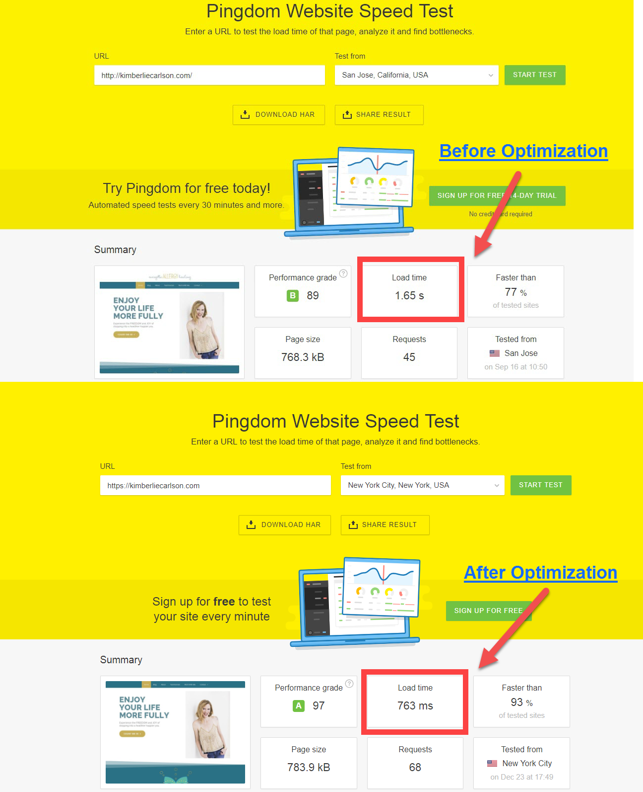

Optimize Your Website Speed
Schedule a call with us at https://thedigitalnavigator.com/strategy to discuss your options for optimizing your website speed. We also have a fully managed hosting solution which includes security updates, ensuring updates are compatible and blazing fast speed (guaranteed to be faster than your current prpovider).

